**Sardar Patel Institute of Technology,Mumbai**

**Department of Computer Science Engineering**

**B.E. Sem-VII- PE-IV (2024-2025)**

**IT 24 - AI in Healthcare**

**Experiment 8: Implement KERAS or Tensorflow model for automatic detection of abnormalities**

**Name: Adwait Purao UID : 2021300101**  **Date : 6/11/24**

**Objective:**

To understand the basics of neural networks ,Convolutional Neural Network (CNN) or other deep learning models and implement them using Keras and TensorFlow,

**Theory:**

Overview of abnormalities in healthcare,CNN and other deep learning models, Keras and TensorFlow libraries.

**Experiment:**

**1.Install Keras and TensorFlow**

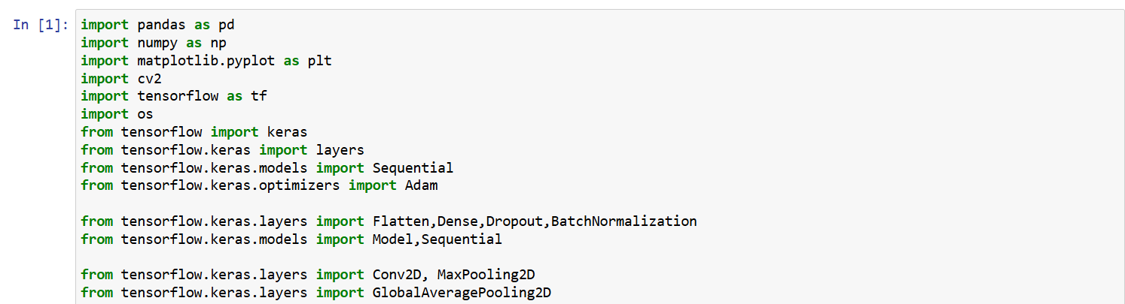

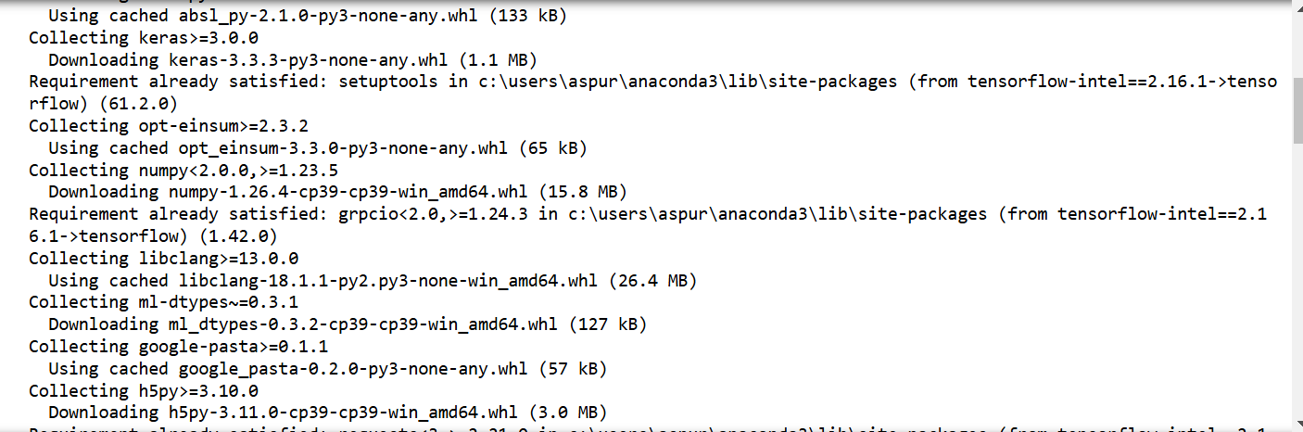

**2. Dataset Preparation**

a.Loading the dataset

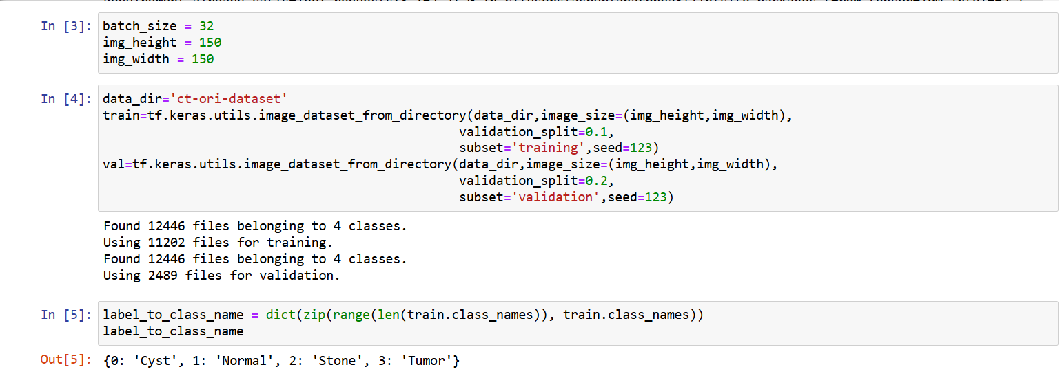

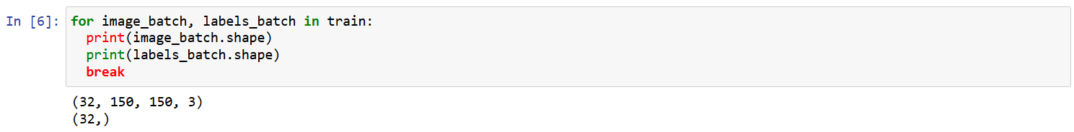

b.Preprocessing the data

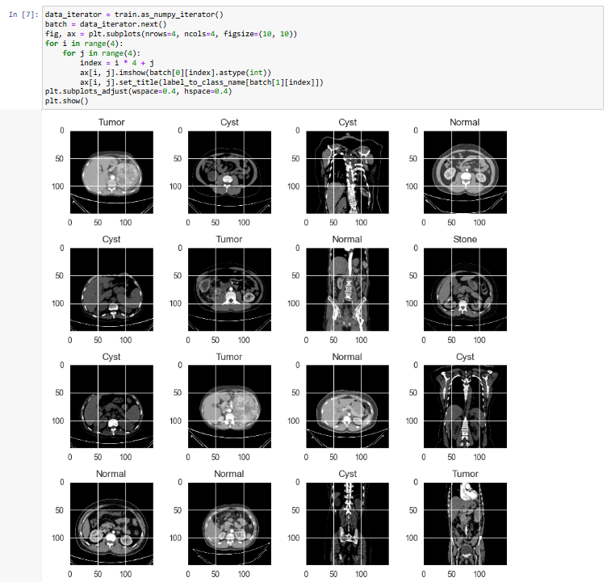

**3.Model Building**

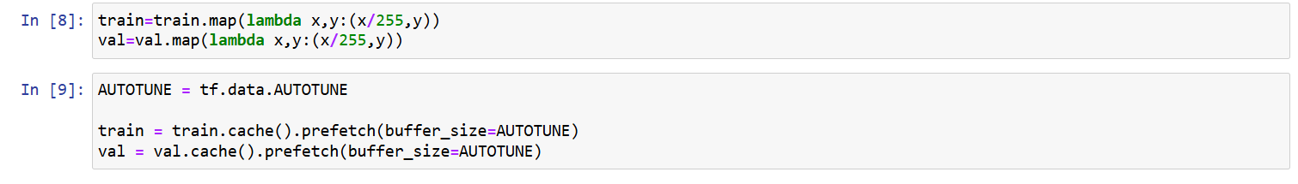

**4. Model Training**

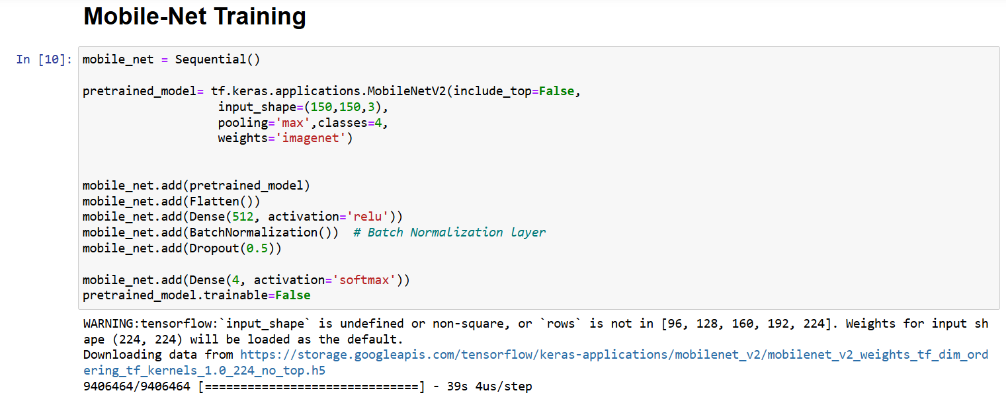

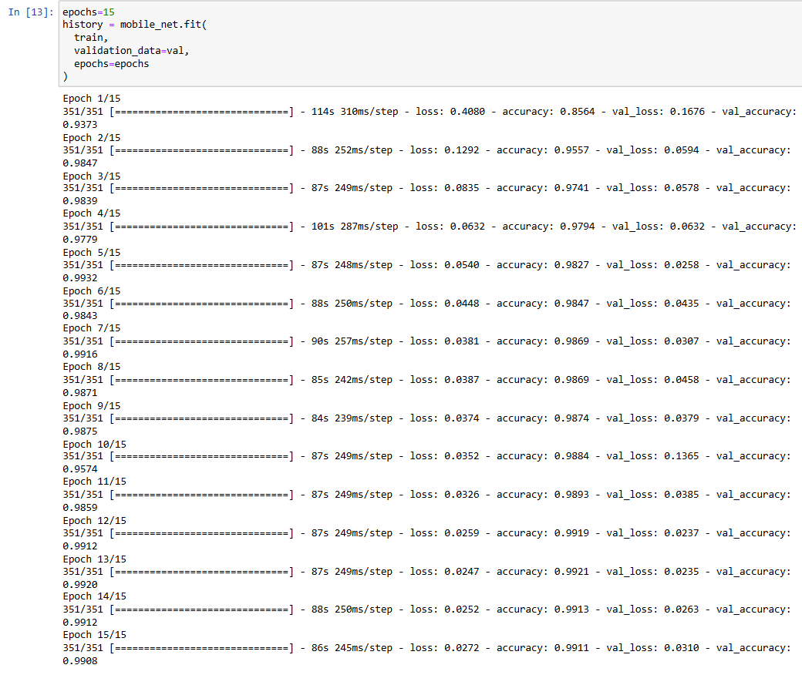

**5. Model Evaluation**

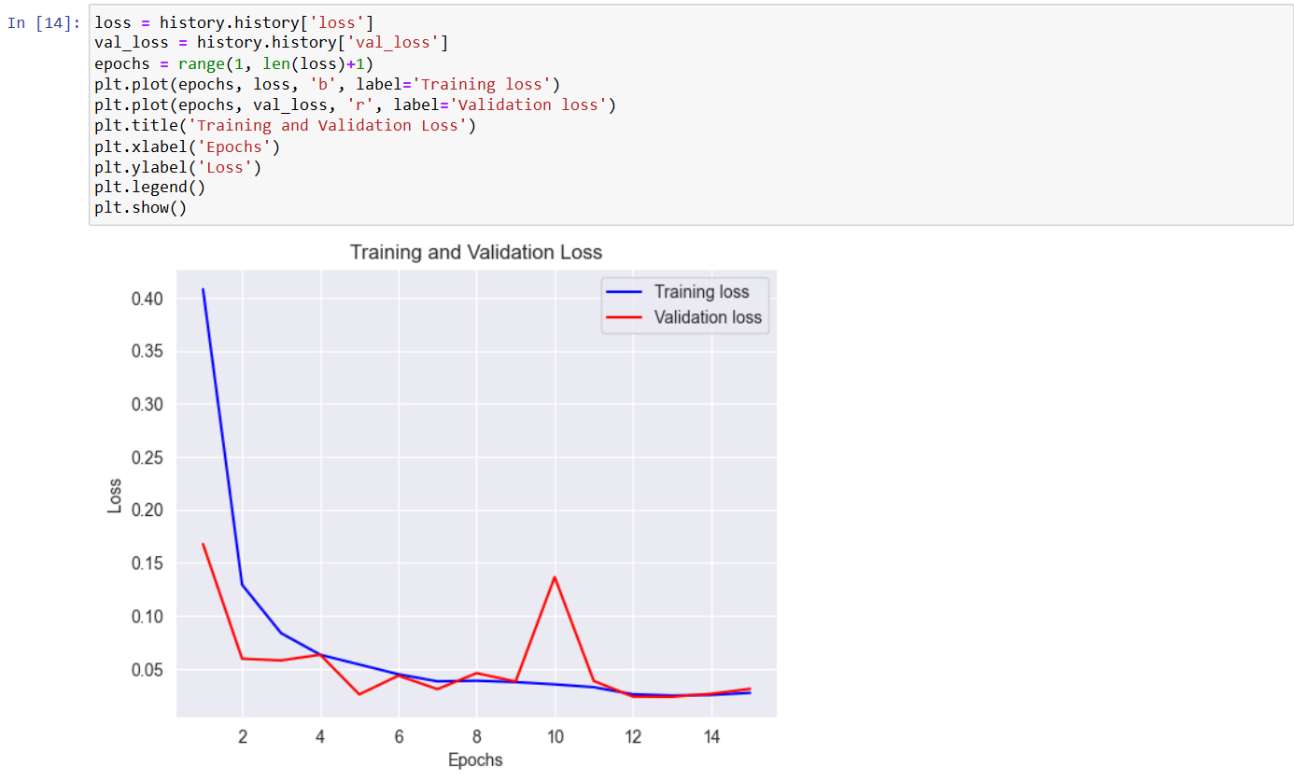

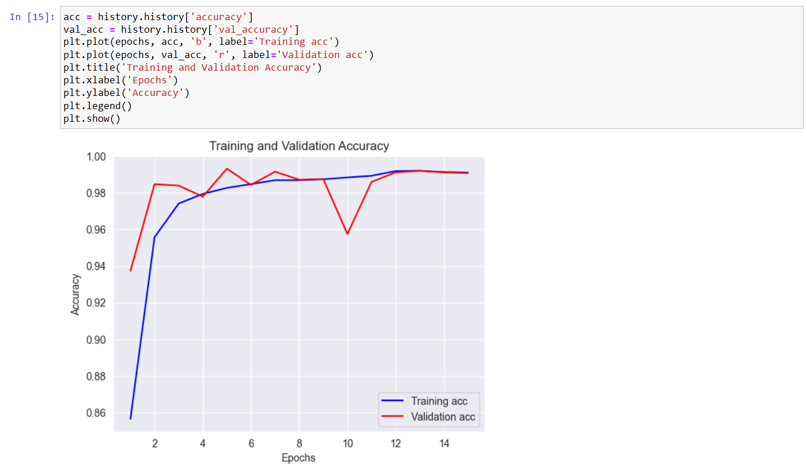

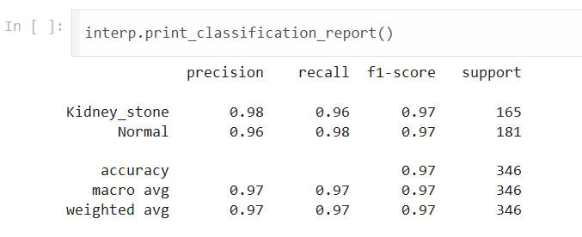

Using performance metrics accuracy, precision, recall, and AUC-ROC.

**6.Testing on new data**

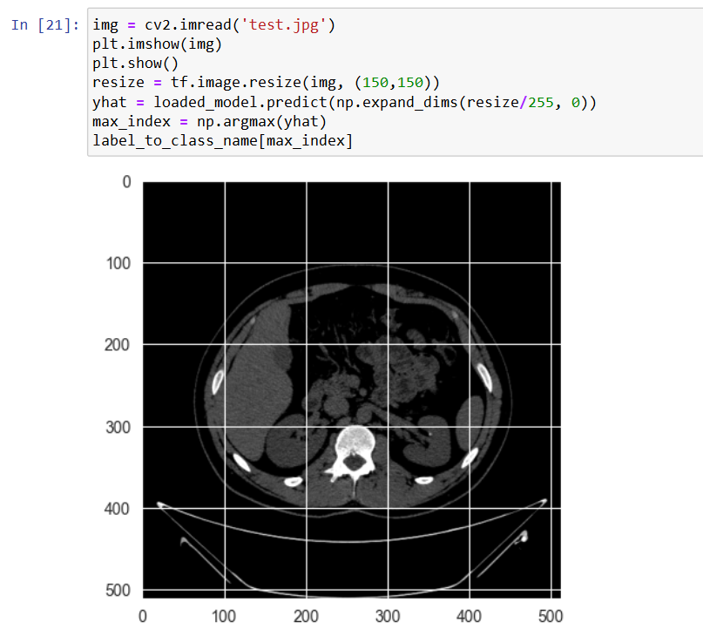

**Conclusion:**

The study illustrates that Convolutional Neural Networks (CNNs), utilizing Keras and TensorFlow, serve as powerful tools for identifying abnormalities in healthcare data. This approach exhibits high levels of accuracy and efficiency in processing medical images and other health-related information, showcasing its potential for practical use in early and accurate diagnosis.